MRI Based Feature Extraction Method for Accurate Diagnosis of Alzheimer’s Disease

Neha Zulfiqar
Dept. of Information Tech nology
Lahore, Pakistan
Nehazulfiqar6543@gmail.com

Dr. Muhammad Farooq
Dept. of Information Tech nology
Lahore, Pakistan
mfarooq@.pucit.edu.pk

Umar Khalil
Dept. of Information Tech nology
Lahore, Pakistan
umarmalikcs@gmail.com

Abstract: Early detection of Alzheimer disease remains a major issue in medical imaging particularly the brain MRIs. The alterations on the brain are so unnoticeable initially that it becomes difficult to analyze. I believe, that is why it is so difficult to appreciate it in time. The latest work in the field of artificial intelligence demonstrates that deep learning can be used to assist with automated diagnosis of neurological problems. Many of those, however, simply apply convolutional networks, and they fail to capture any of the temporal or sequential regularities in the images. That appears to omit some vital dependencies. To resolve this, this paper proposes a hybrid solution that combines machine learning with deep learning to classify Alzheimer in various stages with MRI images. It is multi-class, and thus manages different levels. The first step is the pre-processing of MRI images and extracting the texture information using such techniques as Gray-Level Co-occurrence Matrix, Local Binary Patterns, and Histogram of Oriented Gradients. Those are tested on classical machine learning models. Next is this CNN-LSTM configuration. The CNN component extracts spatial information of the scans, and the LSTM does the sequential information of these feature maps. In that manner, it will know the intricate trends that are associated with the progress of Alzheimer. Makes sense, kind of, to mix space and time-like. They evaluate this deep model using a dataset of four categories, namely, non-demented, very mild demented, mild demented and moderate demented. The findings indicate that the CNN-LSTM performs significantly better than the conventional machine learning models. It reaches a 94% accuracy on average and the features are more discriminating with good generalization. It is easy to imagine some individuals may believe that it is sufficient to use CNN, but this combination of spatial learning and sequential memory is quite impressive. It seems as though it is driving on automated systems to diagnose neurological disorders. The framework has the potential to enable clinicians to diagnose and monitor Alzheimer earlier, making the process of diagnostics more precise and scalable. It is not all superb but this section becomes somewhat messy when considering the application in reality.
Keywords—Machine Learning, Deep Learning, CNN, LSTM, Feature Extraction, HoG, LBP, Classification

Introduction
The primary form of dementia available is basically Alzheimer's disease. It worsens over time, and affect memory of people and thinking or reasoning. Behavior changes too. Typically, it affects older individuals, and makes it difficult for them to carry out daily activities independently and maintain that independence [1].
According to the National Institute on Aging in 2025, there are more than 6 million individuals above 65 years old with it in the US today. And that is only here, numbers are increasing at a rapid rate all over as populations are getting old. It begins with forgetting minor things, slight memory problems I suppose. Then it moves on and you know to larger issues such as failing to talk correctly or perceive situations or mask simple puzzles. With time, even simple activities such as eating or walking become difficult and communication is nearly impossible [2].
The changes that occur in the brain are complicated as I have read. These are protein deposits, amyloid beta plaques and tau tangles that bend the neurons communication with one another. It causes the death of cells. Initiates in the hippocampus, which is involved in forming memories. Then it extends to areas of language and reasoning, even social stuff. That makes the brain shrink, atrophy and cognition simply deteriorates a lot [3].
Such developments as MRI are now able to visualize the changes in the brain. Nevertheless, early diagnosis is still an issue since the differences are not evident at first. The phases are not necessarily distinct in between. Therefore, researchers are promoting machine learning and deep learning algorithms to facilitate the detection of it by physicians in its early stages. That way the classification is more specific. It seems to be prospective, though I am not completely sure of its usefulness in actual circumstances yet. Overall, it is a large-scale health issue, and, indeed, it is pressing, with the number of cases rising.
The Magnetic Resonance Imaging (MRI) is widely used in studying the structural changes in the human brain. Nonetheless, manual examination of MRI images is a tiresome activity and subject to human error. Accordingly, machine learning and deep learning automated systems have gained a lot of interest.
The study proposes a hybrid approach to feature extraction and deep learning techniques to achieve high classification accuracy. The model is based on multi-class classification, including Non-Demented, Very Mild, Mild, and Moderate Alzheimer stages.

Literature Review
Liu et al. [8], developed a multimodal deep learning framework of combining MRI neuroimaging data with clinical assessments. The proposed model is an integration of convolutional neural networks and attention-based approaches that aim to learn structural brain abnormalities and clinical features of cognitive decline. The framework was tested on data collected from 2,847 participants and demonstrated an accuracy of 96.3%, which is higher than accuracy obtained from single modality frameworks. The findings of the study show that deep learning methods can help provide accurate and timely diagnosis of AD and offer clinically interpretable insights for healthcare professionals.
Rossini et al. [9], examined the application of machine learning methods to early detection of dementia, and to the prediction of conversion from Mild Cognitive Impairment (MCI) to Alzheimer's disease (AD). The study highlighted the importance of combining the use of electroencephalography (EEG), neuroimaging, genetic and biochemical biomarkers to enhance the diagnostic accuracy. The authors were able to successfully discriminate pathological brain aging from normal aging using EEG-based functional connectivity measures and graph theory analysis along with machine learning algorithms, specifically Support Vector Machines (SVM). The results showed that the analysis of multimodal biomarkers using machine learning is a promising approach for early detection of high-risk individuals and the development of personalized clinical interventions for dementia management.

Dara et al. [10], give a thorough overview of the machine learning and AI methods used in the diagnosis of Alzheimer's disease. The study summarizes over 80 recent publications and compares the performance of the various machine learning algorithms such as Support Vector Machines (SVM), Decision Trees, Random Forests, and deep learning models in analysing neuroimaging and biomarker data. The authors point out how MRI, PET, EEG and genetic information have become increasingly important in the early and accurate diagnosis. They find that machine learning algorithms for computer-aided diagnostic systems have the potential to enhance the detection, classification, and prediction of disease progression, especially when leveraging multiple modalities of data sources. The study suggests that future research should prioritize advanced feature selection methods, multimodal learning models, explainable AI, and clinically interpretable models to improve diagnostic accuracy and aid in personalized treatment strategies for Alzheimer's disease.

Gao and Lima [11], provide a detailed overview of the use of deep learning techniques in the detection of Alzheimer's disease (AD), highlighting the significance of artificial intelligence in the analysis of medical images. Key biomarkers, data preprocessing methods, feature extraction methods (slice-based, voxel-based, ROI-based, and patch-based), and deep learning architectures (Autoencoders, Deep Belief Networks, Convolutional Neural Networks (CNNs), and Recurrent Neural Networks) are studied. The authors conclude that CNN-based models are consistently superior to traditional machine learning methods, because they are able to automatically learn complex imaging features from MRI, PET and other neuroimaging data. The review points out that deep learning improves the accuracy of diagnosis, especially for early stage AD and mild cognitive impairment (MCI). But there are still problems with low-level data, overfitting, lack of interpretability of models, and the necessity of multimodal data integration to enhance clinical applicability and diagnostic reliability.

Shukla et al. [12], recommended a framework for Alzheimer's disease diagnosis based on image pre-processing methods along with machine learning and deep learning algorithms. The study adopted MRI data in the ADNI database and enhanced the image quality and reduced the amount of computation by selective clipping, grayscale conversion, histogram equalization, and principal component analysis. A Random Forest, XGBoost and Convolutional neural network (CNN) were tested for disease detection. The results revealed that the CNN model had the highest accuracy with 97.57% and sensitivity 97.60%. The study showed that the pre-processing methods have a great impact on the classification accuracy, the model training time, and, therefore, they are important to obtain efficient computer aided diagnostic systems for Alzheimer's disease.

Chabib et al. [13], proposed DeepCurvMRI, a novel deep learning framework which integrates Curvelet Transform (CT) and Convolutional Neural Networks (CNNs) for early detection of Alzheimer's disease in MRI images. To extract discriminative features and reduce noise prior to classification, Fast Discrete Curvelet Transform (FDCT) was used in the study. The suggested model was tested on a set of four classes Alzheimer's MRI dataset, and was evaluated with several cross validation methods such as leave-one-group-out cross validation and k-fold validation. The experimental results showed excellent performance with the multiclass classification accuracy of 98.62% along with high sensitivity and specificity. The results show that the combination of curvelet-based feature extraction and deep learning is able to capture the subtle anatomical variations in the brain MRI images, which improves the accurate diagnosis of Alzheimer's disease.

Chen et al. [14], they purposed advanced deep learning framework for automated classification of Alzheimer's disease (AD) using MRI scans. The model is composed of deep feature extraction network (ResNet50), sequence modeling network (Bidirectional Gated Recurrent Units (Bi-GRU)) and detection and classification network (Faster R-CNN with Soft Non-Maximum Suppression (Soft-NMS)). MRI data were collected from the ADNI dataset of cognitively normal (CN), mild cognitive impairment (MCI) and AD subjects. Results showed excellent classification performance with accuracy of 98.91% between AD and CN, 94.54% between AD and MCI and 92.80% between MCI and CN, which is superior to some of the current methods. The results indicate that a combination of object detection, deep feature learning and temporal sequence modeling can be a powerful tool for early diagnosis of Alzheimer's disease with MR imaging.

Fareed et al. [15], describe a lightweight CNN (Convolutional Neural Network) network named ADD-Net (Alzheimer’s Disease Detection Network) for the early detection and classification of Alzheimer's Disease using MRI scans. The model was created from scratch with reduced number of trainable parameters which makes it appropriate for smaller datasets compared with conventional deep learning architectures. The authors tackled the extreme class imbalance problem of the Kaggle MRI data by using the SMOTETOMEK oversampling method, creating synthetic samples for balancing disease categories. Additionally, ADD-Net used visualization tools (Grad-CAM) to identify brain regions that contribute to classification decisions. In the experiments, a high accuracy of 98.63%, AUC of 99.76% and F1-score of 98.61% were obtained, along with good recall of 98.58% and precision of 98.58%, showing its effectiveness for automated Alzheimer's disease diagnosis when compared to DenseNet169, VGG19 and InceptionResNet V2.

Alsharabi et al. [16], they purposed electroencephalogram (EEG) based computer-aided diagnostic (CAD) system for the detection of Alzheimer's disease using Discrete Wavelet Transform (DWT) and machine learning techniques. EEG signals were first pre-processed by applying elliptic band pass filter followed by DWT for sub-band decomposition of the EEG signal into frequency sub-bands. Nine machine learning algorithms were used to extract and classify the statistical features such as logarithmic band power, kurtosis, average energy, RMS and norm. KNN (K Nearest Neighbor), one of the tested classifiers, showed the best performance with 99.98% maximum accuracy, 100% AUROC (Area Under The ROC Curve) for the Alzheimer's patients and healthy controls. The results show that the wavelet-based analysis of EEG has potential in the early detection of Alzheimer's disease; however, the results are restricted to the use of a single dataset and lack external validation.

Collectively, the reviewed studies demonstrate the growing potential of machine learning and deep learning techniques in improving the early detection and classification of Alzheimer’s disease. Since the use of MRI, PET, clinical and EEG data, various approaches have been reported such as multimodal learning frameworks, convolutional neural networks, recurrent neural networks, EEG based approaches, and hybrid feature extraction methods, yet they have reported high diagnostic performance. The findings of these studies emphasize the significance of efficient feature extraction, data fusion, and sophisticated classification methods for detecting patterns associated with diseases and discriminating between various stages of cognitive impairment. However, there are still some outstanding issues regarding the diversity of datasets, interpretability of the models, external validation, and clinical applicability in real-world settings. Thus, more studies are needed to establish a robust, accurate and clinically reliable diagnostic model that can help in early intervention and enhance patient care in the management of Alzheimer's disease.

Methodology
This section shows the overall methodology that was used to automate the classification of the severity of Alzheimer disease based on MRI brain scans. The proposed framework combines two complementary paradigms: (1) a classical machine learning pipeline, which is characterized by handcrafted feature extraction and dimensionality reduction, and sweet ssupervised classification; (2) a deep learning pipeline, which is characterized by a hybrid Convolutional Neural Network-Long Short-Term Memory (CNN-LSTM) architecture, end-to-end feature learning and classification. Fig. 1 represents a high-level view of the entire system.

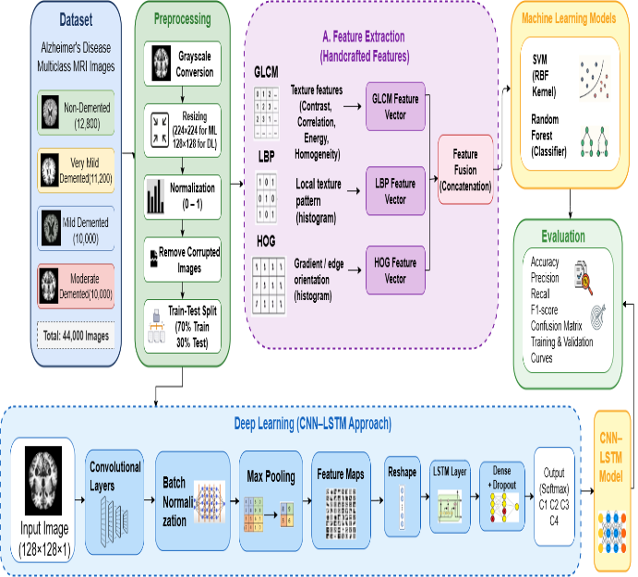
- METHODOLOGY

Dataset Description

The experiments were performed on a publicly available Alzheimer's disease MRI dataset, which was divided into four diagnostic categories: Non-Demented (ND), Very Mild Demented (VMD), Mild Demented (MD), and Moderate Demented (MoD). Each picture is a grayscale axial brain MRI in the usual raster format (PNG/JPG). There is a significant class imbalance in the dataset, which is explicitly dealt with in training as defined in Section III-C. The following was the mapping of classes to indices:

$$C = \left\{ND → 0, VMD → 1, MD → 2, MoD → 3\right\}\left(1\right)$$

Image paths and integer labels were programmed through enumeration by walking through per-class sub-directories, and the resultant collection is an aggregate used in both pipelines. Table I shows the class-wise distribution of the MRI images in the Alzheimer's disease dataset.

- Class-Wise Distribution of MRI Dataset
Class Label | Non-Demented | Very Mild Demented | Mild Demented | Moderate Demented
No. of Images | 12,800 | 11,200 | 10,000 | 10,000

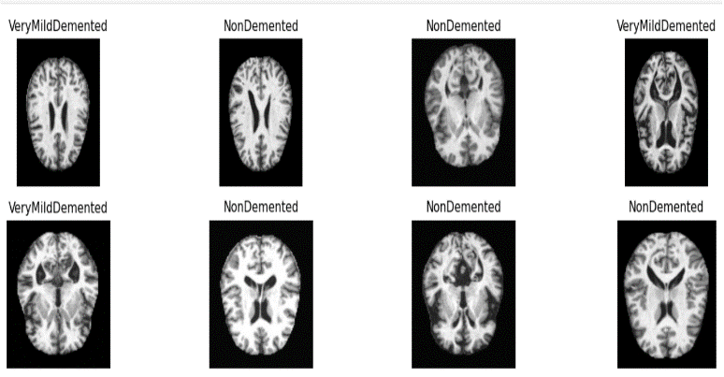


- DATASET CLASSES

Data Preprocessing
Raw MRI images were analyzed through a two-step process of preprocessing before feature extraction or model ingestion.
- Resizing and Grayscale Conversion: All images were read in grayscale mode with OpenCV and downsized to a constant spatial resolution. In the case of the classical machine learning pipeline, the images were resized to 224 by 224 pixels, applying the area interpolation (INTER_AREA) method, which is the best downsampling approach since it reduces aliasing artefacts. In the case of the deep learning pipeline, the images were downsampled to 128 × 128 pixels to trade space and computing power.
- Intensity Normalization: For the classical pipeline, pixel intensities were normalized to the range [0, 1] using min–max normalization:
$$I_{norm\left(x, y\right)}= \frac{\left(I\left(x, y\right)- I_{min}\right)}{\left(I_{\max{-}I_{\min{+}ε}}\right)}\left(2\right)$$
In Eq. (2), I_{(x, y)} is the intensity of the pixel at (x, y), I_{min} and I_{max} are the lowest and highest intensities of the image, and ε = 1×10⁻⁸ is a small constant to prevent division by zero. In the deep learning pipeline, the pixel values were scaled to the range [0, 1], divided by 255 to reshape into the four-dimensional texture format (N × H × W × 1).

Classical Machine Learning Pipeline
The classical pipeline consists of three sequential stages: handcrafted feature extraction, dimensionality reduction, and multi-class classification.
1) Handcrafted Feature Extraction: Each of the preprocessed images was converted into three complementary feature descriptors which were concatenated to a single composite feature vector.
a) Gray-Level Co-occurrence Matrix (GLCM): Texture measures were calculated using the GLCM, based on 256 gray levels, symmetric co-occurrence, and probability normalization, with spatial distances of d = 1 and 4 orientation angles of θ ∈ {0°, 45°, 90°, 135°,} with 256 gray levels, symmetric co-occurrence, and probability normalization. The resulting GLCM tensors produced six statistical properties, including contrast, dissimilarity, homogeneity, energy, correlation, and Angular Second Moment (ASM). The feature sub-vector of each property p is:
$$f_{GLCM\left(p\right)}= \left[ρ_{p\left(d_{i}, θ_{j}\right)}\right] ∀ i ∈ \left\{1,2\right\}, j ∈ \left\{1,2,3,4\right\}\left(3\right)$$
producing a 48-dimensional GLCM feature sub-vector (6 properties × 2 distances × 4 angles).
b) Local Binary Pattern (LBP): The uniform LBP operator was used to take micro-texture features with sampling points P = 8 and radius R = 1. The LBP value of the pixel is determined as:
$$LBP_{\left\{P,R\right\}\left(x,y\right)}= Σ_{\left\{p=0\right\}}^{\left\{P-1\right\}s\left(g_{p}- g_{c}\right)}· 2^{p}\left(4\right)$$
where g_{c} is the intensity of the central pixel, g_{p} is the intensity of the p-th neighbor on a circle of radius R, and s(·) is the sign function. The LBP feature sub-vector is represented by a normalized histogram over the n_{bins} = maximum possible pattern of LBP +1 uniform patterns.
c) Histogram of Oriented Gradients (HOG): HOG descriptors were used to encode shape and edge information based on 9 orientation bins, a cell size of 16 × 16, a block size of 2 x 2 cells, and L2-Hys block normalization. The HOG magnitude of a gradient element at pixel (x, y) is:
$$m\left(x,y\right) = \sqrt{ f_{x\left(x,y\right)}^{2}+ f_{y\left(x,y\right)}^{2}}\left(5\right)$$
f_{x} and f_{y} are the horizontal and vertical gradient responses, respectively. The entire HOG descriptor is obtained by summing up the signed orientations across cells and averaging across overlapping blocks. The overall composite feature vector of a given image is simply the combination of all three sub-vectors:
$$x = \left[ f_{GLCM} \right\| f_{LBP} \left\| f_{HOG}\right] ∈ R^{D}\left(6\right)$$
where D is the total dimensionality of the individual lengths of the descriptors.
2) Dataset Partitioning: The feature matrix X ∈ ℝ^{{N×D}} and label vector y ∈ Z^{N} were randomly split into a 20 percent test set and a training set using a stratified random split and a random seed (seed = 42), ensuring that the distribution of classes between the two sets was similar.
3) Class Imbalance Handling: To reduce the negative impact of imbalance between the classes, the training set only underwent Random Over-Sampling (ROS) with an imbalanced-learn pipeline, so that the test set would not be affected and would operate as an unbiased evaluation.
4) Feature Scaling and Dimensionality Reduction: All the features were normalized with a z-score:
$$x_{i}^{'} = \frac{\left(x_{i}- μ\right)}{σ}\left(7\right)$$
where μ and σ are the mean and standard deviation calculated on the training set. Principal Component Analysis (PCA) was then performed with enough components to capture 95% of the cumulative variance to minimize the dimensions of features without losing the most discriminative information.
5) Classifiers: The following three classifiers have been tested in the unified imbalanced-learn pipeline: (i) Support Vector Machine with RBF kernel (SVM-RBF), class_weight = "balanced", (ii) Random Forest Classifier with 400 estimators and balanced_subsample class weighting, and (iii) Logistic Regression with up to 2000 solver iterations and balanced class weights. All the classifiers were trained using the training features that had been oversampled, scaled and PCA-transformed.

Deep Learning Pipeline: Hybrid CNN-LSTM Architecture
The deep learning pipeline uses a hybrid CNN-LSTM architecture where convolutional layers are used to extract spatial features and an LSTM layer to extract sequential dependencies over the feature representation.
1) Convolutional Feature Extraction Block: The CNN backbone is composed of three successive convolutional blocks. Both blocks use a 2D convolution with a 3 × 3 kernel, then ReLU activation and max-pooling with a 2 × 2 pool size, and the first two blocks also use Batch Normalization to stabilize the training process. The three blocks have a progressive increase in the number of filters: 32, 64 and 128. The convolutional transformation of a feature map F^{(l)} at a layer l is:
$$F^{\left(l\right)\left(i, j, k\right)}= ReLU\left( Σ_{\left\{m,n,c\right\}W_{\left\{m,n,c,k\right\}}^{l}}· F^{\left(l-1\right)\left(i+m, j+n, c\right)}+ b_{k}^{l}\right)\left(8\right)$$
Where W^{(l)} are the variables to be learned in the filter weights, b^(l) are bias variables, and (m, n) denote the spatial size of the 3 x 3 kernel. The result of the third convolutional block is flattened into one-dimensional x_{flat} ∈ ℝ_{d}.
2) Sequence Reshaping and LSTM Layer: The flattened vector is rearranged into a sequence tensor of size (1, d), which consists of a single time step and is passed to an LSTM layer with 128 hidden units. The LSTM processes the input through its gating process to generate a fixed-length context representation h_{t}:
$$f_{t}= σ\left(W_{f}· \left[h_{\left\{t-1\right\}}, x_{t}\right]+ b_{f}\right)\left(9\right)$$
$$i_{t}= σ\left(W_{i}· \left[h_{\left\{t-1\right\}}, x_{t}\right]+ b_{i}\right)\left(10\right)$$
$${\tilde{c}}_{t}=\tanh\left(W_{c}· \left[h_{\left\{t-1\right\}}, x_{t}\right]+ b_{c}\right)\left(11\right)$$
$$c_{t}= f_{t}⊙ c_{\left\{t-1\right\}}+ i_{t}⊙ {\tilde{c}}_{t}\left(12\right)$$
$$o_{t}= σ\left(W_{o}· \left[h_{\left\{t-1\right\}}, x_{t}\right]+ b_{o}\right)\left(13\right)$$
$$h_{t}= o_{t}⊙\tanh\left(c_{t}\right)\left(14\right)$$
where f_{t}, i_{t}, o_{t} are the forget, input, and output gates, respectively, c_{t} is the cell state, σ(·) denotes the sigmoid function; and ⊙ denotes element-wise multiplication.
3) Classification Head: The LSTM output h_{t} is forwarded through a fully connected layer with 64 units, ReLU activation, and a Dropout layer with rate p = 0.5 to regularize. The last output layer uses 4 softmax-activated neurons to generate a distribution of class probabilities:
$$ŷ_{k} =\frac{\exp\left(z_{k}\right)}{Σ_{\left\{j=1\right\}}^{\left\{4\right\}exp}\left(z_{j}\right)}, k ∈ \left\{0, 1, 2, 3\right\}\left(15\right)$$
where z_{k} is the pre-activation logit for class k, and ŷ_{k} is the predicted probability for that class.
4) Training Configuration: The model was trained with Adam optimizer, learning rate of α = 1 × 10⁻⁴ and categorical cross-entropy loss:
$$L = - Σ_{{\left\{k=1\right\}}_{k}^{\left\{4\right\}y}}·\log\left(ŷ_{k}\right)\left(16\right)$$
where y_{k} ∈ {0, 1} is the one-hot ground-truth label for class k. Training was performed for 25 epochs with a mini-batch size of 32 on the stratified 80/20 training split, with simultaneous monitoring of validation accuracy and loss to detect overfitting.

Evaluation Metrics
The four common measures of multi-class classification accuracy, precision, recall (sensitivity), and F1-score were used to measure model performance on the held-out test set. Multi-class Area Under the Receiver Operating Characteristic Curve (ROC-AUC) was also calculated with the one-vs-rest (OvR) approach with the classical classifiers. All models were run and confusion matrices created to give a breakdown of the errors per-class. In the case of the deep learning model, the ROC curves were plotted individually by each class using binarized ground-truth labels and the respective predicted probabilities. The F1-score of class c is given as:
$$F1_{c} = 2 ·\frac{\left(P_{c}· R_{c}\right)}{\left(P_{c}+ R_{c}\right)}\left(17\right)$$
Where P_{c} and R_{c} are the class c precision and recall, respectively. The main scalar performance measure is the macro-averaged F1-score across all four classes to consider class imbalance.

Visualization and Feature Analysis
In order to decode the learned feature space and authenticate the separability of classes, two dimensionality reduction methods were utilized on the handcrafted feature matrix, which had been normalized by the z-score. Initially, a linear visualization was projected on the first two principal components in PCA. Second, a non-linear visualization of the high-dimensional feature manifold was implemented with t-Distributed Stochastic Neighbor Embedding (t-SNE) using perplexity = 30 on a randomly selected sample of 2,000 samples. Moreover, a Random Forest model was fitted on the complete set of features to calculate the feature importance scores through the mean decrease in impurity and the top-20 most discriminative features were selected. The monitoring of training and validation accuracy/loss curves was performed at all 25 epochs to evaluate the model convergence and overfitting behavior.

Results and Evaluation

Experimental Setup

A multi-stage Alzheimer’s disease MRI dataset, comprising of four classes of NonDemented, VeryMildDemented, MildDemented and ModerateDemented was used for evaluation of the purposed model. A stratified 80:20 split of the data was used to create training and testing sets, with care taken to ensure the classes were balanced.
To build the machine learning pipeline, the handcrafted features such as Gray Level Co-occurrence Matrix (GLCM), Local Binary Patterns (LBP) and Histogram of Oriented Gradients (HOG) were extracted and concatenated to get a high dimensional feature vector. These features were transformed to unit variance and mean and reduced using Principal Component Analysis (PCA) with 95% of the variance retained. Random Over Sampling (ROS) has been employed in the training process to overcome the class imbalance problem.
The classifiers used were Support Vector Machine (SVM) RBF, Random Forest and Logistic Regression. Furthermore, a deep learning model of CNN-LSTM was developed to model both spatial and sequential information of the MRI images. The deep learning model was trained for 25 epochs with Adam optimizer and categorical cross-entropy loss.

Performance Metrices
The performance of all models was evaluated using standard classification metrics including:
- Accuracy
- Precision
- Recall
- F1-score
- Confusion Matrix
- ROC-AUC (One-vs-Rest for multi-class classification)
These metrics provide a comprehensive evaluation of model effectiveness, particularly for medical diagnosis tasks where class imbalance and misclassification costs are critical.

Machine Learning Result
Handcrafted features in conjunction with PCA were used to create machine learning models, which showed competitive performances. Random Over Sampling was used to improve the class balance and to improve the classification results.
With the capability of handling a high dimensional feature space, SVM classifier gave stable performance. Random Forest was used to gain insights on feature importance, which included the features derived from texture. Logistic Regression (Softmax) was used as a base line comparison and also showed reasonable performance in the case of multi-class classification.
- ML model Result
Model | Precision | Recall | F1-Score | Accuracy
Logistic Regression | 0.78 | 0.78 | 0.78 | 0.78
Random Forest | 0.82 | 0.82 | 0.82 | 0.82
SVM (RBF Kernel) | 0.91 | 0.91 | 0.91 | 0.91

The comparative performance of the three machine learning models used for dementia classification is shown in Table I. The SVM model that employs RBF kernel produced the best classification performance with the accuracy of 91%, precision, recall and F1 score of 0.91. Random Forest model showed moderate performance with 82% accuracy while Logistic Regression model showed the lowest performance with 78% accuracy. Moreover, SVM always outperformed other models in all dementias classes especially in Moderate Demented class with F1-score of 0.98. The results show that SVM with RBF kernel is the most appropriate model for the proposed classification task because of its non-linear decision boundary, which helps for better discrimination between the different dementia stages.

Deep Learning Result
The CNN-LSTM model achieved improved classification performance compared to traditional machine learning approaches. The convolutional layers effectively extracted spatial features from MRI images, while the LSTM layer captured dependencies between extracted features.
- ML MODEL RESULT
Model | Precision | Recall | F1-Score | Accuracy
CNN+LSTM | 0.94 | 0.95 | 0.94 | 0.94

The proposed model obtained an overall accuracy of 94%, precision, recall, and F1 score score of 0.94, 0.95, and 0.94 respectively in macro-average. The findings show good performance in the model for multi-class dementia classification with a robust performance in each disease class.
- Training Vs Validation Accuracy Curve
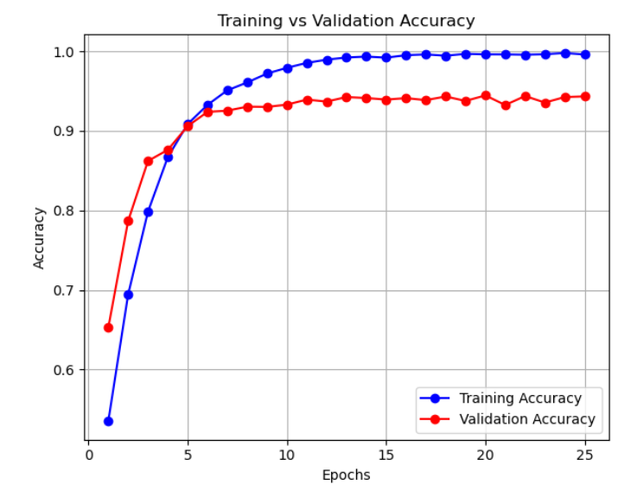
The accuracy curve indicates steady improvement in model performance across epochs, with minimal divergence between training and validation accuracy, suggesting good generalizatio
- Accuracy Curve
- Training Vs Validation Loss Curve
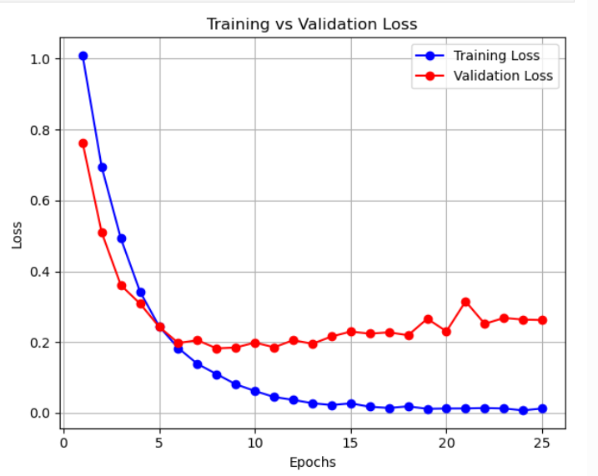
The loss curve demonstrates consistent convergence, indicating that the model effectively minimized classification error without significant overfitting.
- Loss Curve

Confusion Matrix Analysis
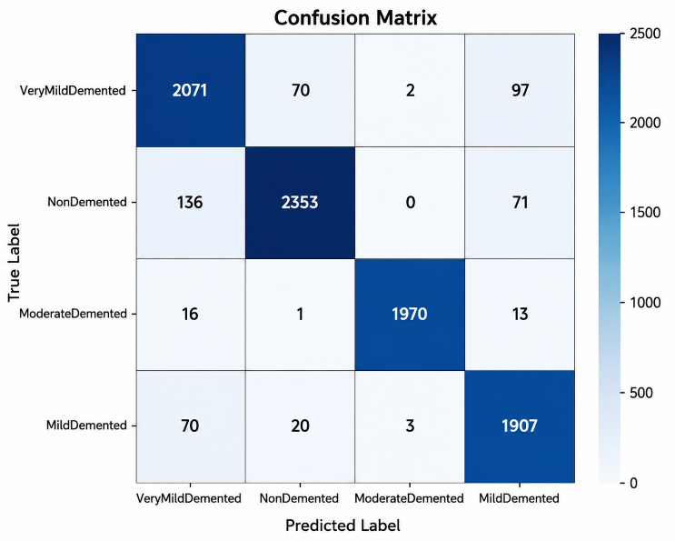
The confusion matrix shows that the model performs well across all four classes. However, minor misclassifications are observed between closely related classes such as VeryMildDemented and MildDemented, which is expected due to subtle structural differences in early disease stages.

- Confusion Matrix

Discussion
The results obtained from the experiments show that the hybrid framework is capable of successfully fusing handcrafted feature extraction and deep learning approaches for the classification of Alzheimer's disease. Random over sampling helps to increase the balance among classes and PCA helps to reduce the feature redundancy and increase the computational efficiency.
The CNN-LSTM model is able to capture both spatial and temporal information into the MRI images resulting in better performance than traditional machine learning-based classifiers. A little bit of misclassification of the early stages of the disease shows that there might be some scope for improvement with attention mechanisms and/or larger data sets. Finally, it is concluded that the proposed approach is a highly robust and effective approach to the multi-stage detection of Alzheimer's disease, and is highly useful for clinical applications.

Conclusion
The study suggests to detect the AD using a hybrid approach of feature engineering and deep learning. This proposed technique works well in terms of meaningful feature extraction, dimensionality reduction and classification performance. The experimental results demonstrate that the fused handcrafted features along with the deep learning models enhance the detection accuracy and robustness. The framework may be used as a tool to reliably diagnose Alzeimer's disease automatically.
In this study we introduce a hybrid framework on multi-class Alzheimer's Disease classification using both hand craft feature extraction techniques (GLCM, LBP, HOG) and deep learning model (CNN-LSTM). This approach differs from other traditional ones, which either depend on handcrafted features or deep learning, as it incorporates both. Additionally, the performance and generalization of the model is enhanced after the feature optimization by PCA and class imbalance by Random over sampling. Various classifiers and deep learning models are used to provide a thorough evaluation of the classifiers' results.

References
- Lane, C. A., Hardy, J., & Schott, J. M. (2018). Alzheimer's disease. European journal of neurology, 25(1), 59-70.
- Vieira, S., Pinaya, W. H., & Mechelli, A. (2017). Using deep learning to investigate the neuroimaging correlates of psychiatric and neurological disorders: Methods and applications. Neuroscience & Biobehavioral Reviews, 74, 58-75.
- Mudrazija, S., Aranda, M. P., Gaskin, D. J., Monroe, S., & Richard, P. (2025). Economic burden of Alzheimer disease and related dementias by race and ethnicity, 2020 to 2060. JAMA Network Open, 8(6), e2513931.
- K. Elissa, “Title of paper if known,” unpublished.
- R. Nicole, “Title of paper with only first word capitalized,” J. Name Stand. Abbrev., in press.
- Y. Yorozu, M. Hirano, K. Oka, and Y. Tagawa, “Electron spectroscopy studies on magneto-optical media and plastic substrate interface,” IEEE Transl. J. Magn. Japan, vol. 2, pp. 740–741, August 1987 [Digests 9th Annual Conf. Magnetics Japan, p. 301, 1982].
- M. Young, The Technical Writer’s Handbook. Mill Valley, CA: University Science, 1989.
- Liu, W., Fan, S., & Weng, G. (2025). Multi-modal deep learning framework for early Alzheimer's disease detection using MRI neuroimaging and clinical data fusion. Annals of Applied Sciences, 6(1).
- Rossini, P. M., Miraglia, F., & Vecchio, F. (2022). Early dementia diagnosis, MCI‐to‐dementia risk prediction, and the role of machine learning methods for feature extraction from integrated biomarkers, in particular for EEG signal analysis. Alzheimer's & Dementia, 18(12), 2699-2706.
- Dara, O. A., Lopez-Guede, J. M., Raheem, H. I., Rahebi, J., Zulueta, E., & Fernandez-Gamiz, U. (2023). Alzheimer’s disease diagnosis using machine learning: a survey. Applied Sciences, 13(14), 8298.
- Gao, S., & Lima, D. (2022). A review of the application of deep learning in the detection of Alzheimer's disease. International Journal of Cognitive Computing in Engineering, 3, 1-8.
- Shukla, G. P., Kumar, S., Pandey, S. K., Agarwal, R., Varshney, N., & Kumar, A. (2023). Diagnosis and detection of Alzheimer's disease using learning algorithm. Big Data Mining and Analytics, 6(4), 504-512.
- Chabib, C. M., Hadjileontiadis, L. J., & Al Shehhi, A. (2023). DeepCurvMRI: Deep convolutional curvelet transform-based MRI approach for early detection of Alzheimer’s disease. IEEE Access, 11, 44650-44659.
- Chen, Y., Wang, L., Ding, B., Shi, J., Wen, T., Huang, J., & Ye, Y. (2024). Automated Alzheimer's disease classification using deep learning models with Soft-NMS and improved ResNet50 integration. Journal of Radiation Research and Applied Sciences, 17(1), 100782.
- Fareed, M. M. S., Zikria, S., Ahmed, G., Mahmood, S., Aslam, M., Jillani, S. F., ... & Asad, M. (2022). ADD-Net: an effective deep learning model for early detection of Alzheimer disease in MRI scans. IEEE Access, 10, 96930-96951.
- AlSharabi, K., Salamah, Y. B., Abdurraqeeb, A. M., Aljalal, M., & Alturki, F. A. (2022). EEG signal processing for Alzheimer’s disorders using discrete wavelet transform and machine learning approaches. IEEE Access, 10, 89781-89797.

